Exercise 2: Creating and Rendering React Components

Aim
To create a React application named ‘StudentApp’, create multiple class components (Home, About, and Contact), and render them in the main application.

Theory Questions and Answers
1. Explain React Components.
A React Component is an independent and reusable piece of code that returns HTML elements through JSX. Components help divide the user interface into smaller, manageable parts.
Advantages:
- Reusability
- Easy maintenance
- Better code organization
- Faster development

2. Difference Between Components and JavaScript Functions
React Component | JavaScript Function
Returns JSX (UI elements) | Returns values
Used to build UI | Used to perform tasks
Can maintain state | Cannot maintain React state by default
Rendered by React | Executed directly by JavaScript
Component names start with uppercase letters | Function names can be any valid identifier

3. Types of Components in React
1. Functional Components
- Simple JavaScript functions.
- Return JSX.
- Easier to write and understand.
Example:
function Home() {
return <h1>Home Component</h1>;
}
2. Class Components
- ES6 classes extending React.Component.
- Can use state and lifecycle methods.
- Must contain a render() method.
Example:
class Home extends React.Component {
render() {
return <h1>Home Component</h1>;
}
}

4. Explain Class Component
A Class Component is a JavaScript class that inherits from React.Component and contains a render() method to display UI elements.
Syntax:
class ComponentName extends React.Component {
render() {
return (
<h1>Hello World</h1>
);
}
}
Features:
- Supports state
- Supports lifecycle methods
- Reusable
- Suitable for complex applications

5. Explain Functional Component
A Functional Component is a JavaScript function that returns JSX.
Syntax:
function Home() {
return (
<h1>Hello World</h1>
);
}
Features:
- Easy to create
- Lightweight
- Faster development
- Supports Hooks

6. Define Component Constructor
A Constructor is a special method in a class component used to initialize the component's state and bind methods.

Syntax:
constructor(props) {
super(props);
this.state = {
name: "Student"
};
}
Purpose:
- Initialize state
- Bind event handlers
- Execute setup code

7. Define render() Function
The render() function is a mandatory method in class components that returns JSX to be displayed on the screen.
Syntax:
render() {
return (
<h1>Hello React</h1>
);
}
Purpose:
- Generates UI
- Returns JSX
- Updates view whenever state changes

Procedure
Step 1: Create React Project
Open Terminal in VS Code and execute:
npx create-react-app StudentApp

Step 2: Navigate to Project Folder
cd StudentApp

Step 3: Create Components Folder
Inside the src folder create:
src
└── Components

Step 4: Create Home Component
Create file:
src/Components/Home.js
Code:
import React, { Component } from 'react';
class Home extends Component {
render() {
return (
<div>
<h2>Welcome to the Home page of Student Management Portal</h2>
</div>
);
}
}
export default Home;
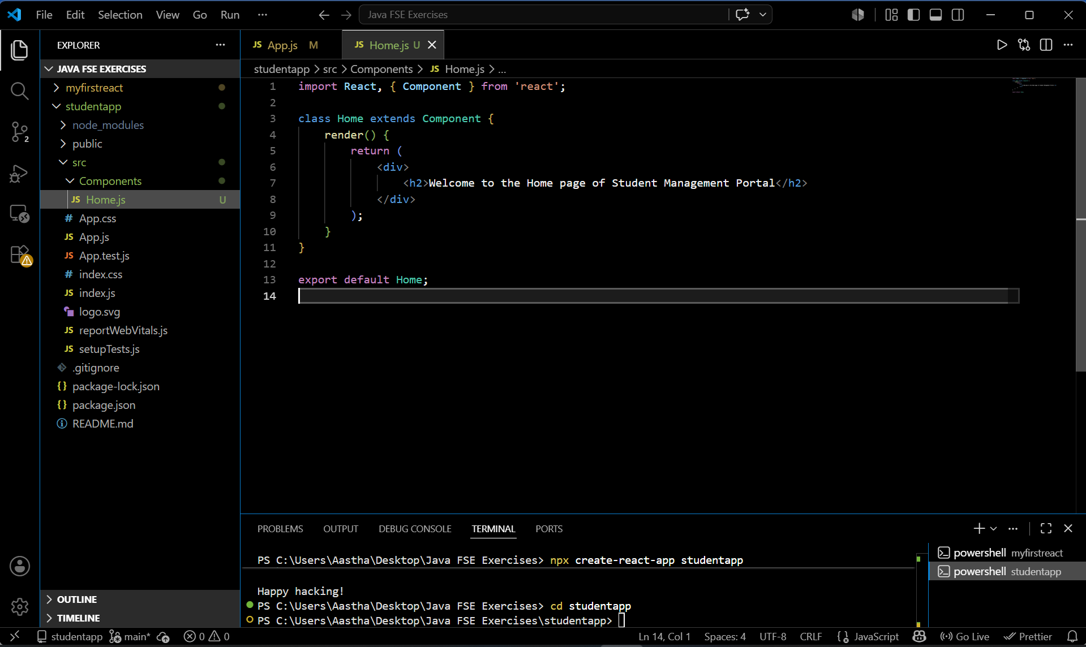

Step 5: Create About Component
Create file:
src/Components/About.js
Code:
import React, { Component } from 'react';
class About extends Component {
render() {
return (
<div>
<h2>Welcome to the About page of Student Management Portal</h2>
</div>
);
}
}
export default About;
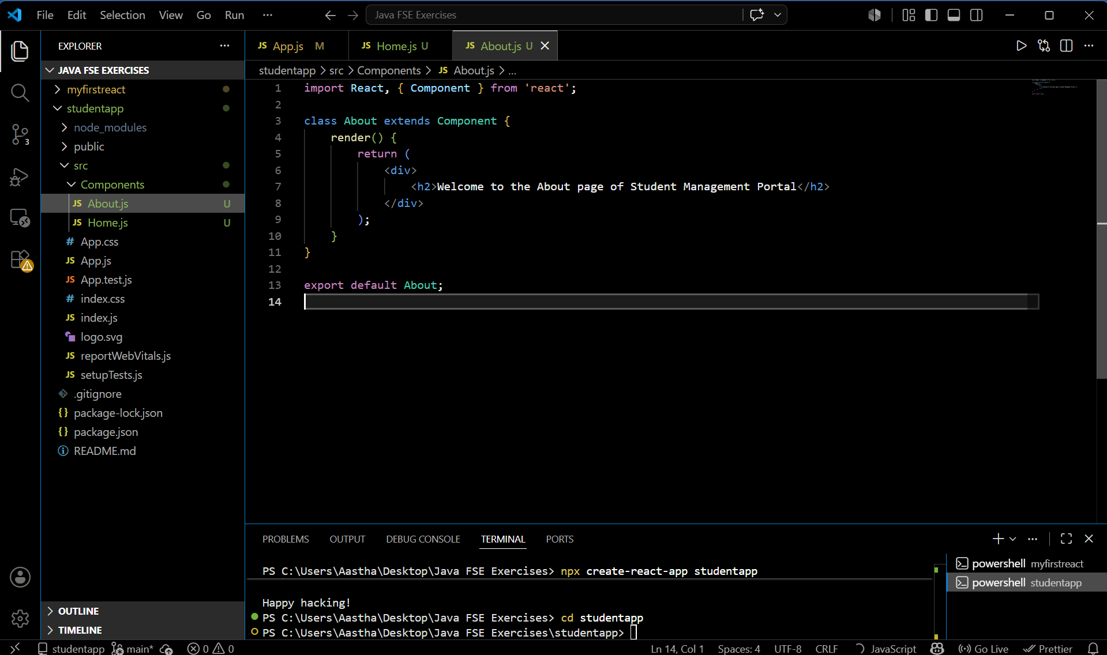

Step 6: Create Contact Component
Create file:
src/Components/Contact.js
Code:
import React, { Component } from 'react';
class Contact extends Component {
render() {
return (
<div>
<h2>Welcome to the Contact page of Student Management Portal</h2>
</div>
);
}
}
export default Contact;
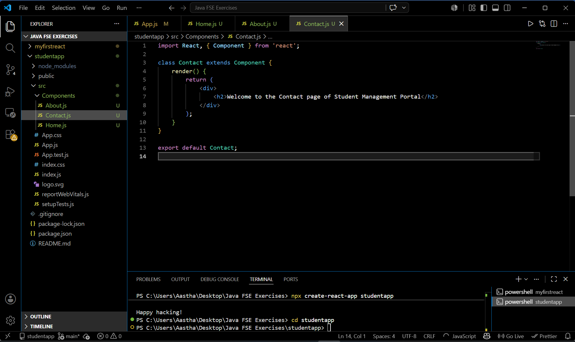

Step 7: Edit App.js
Open:
src/App.js
Replace the existing code with:
import React from 'react';
import Home from './Components/Home';
import About from './Components/About';
import Contact from './Components/Contact';
function App() {
return (
<div>
<Home />
<About />
<Contact />
</div>
);
}
export default App;
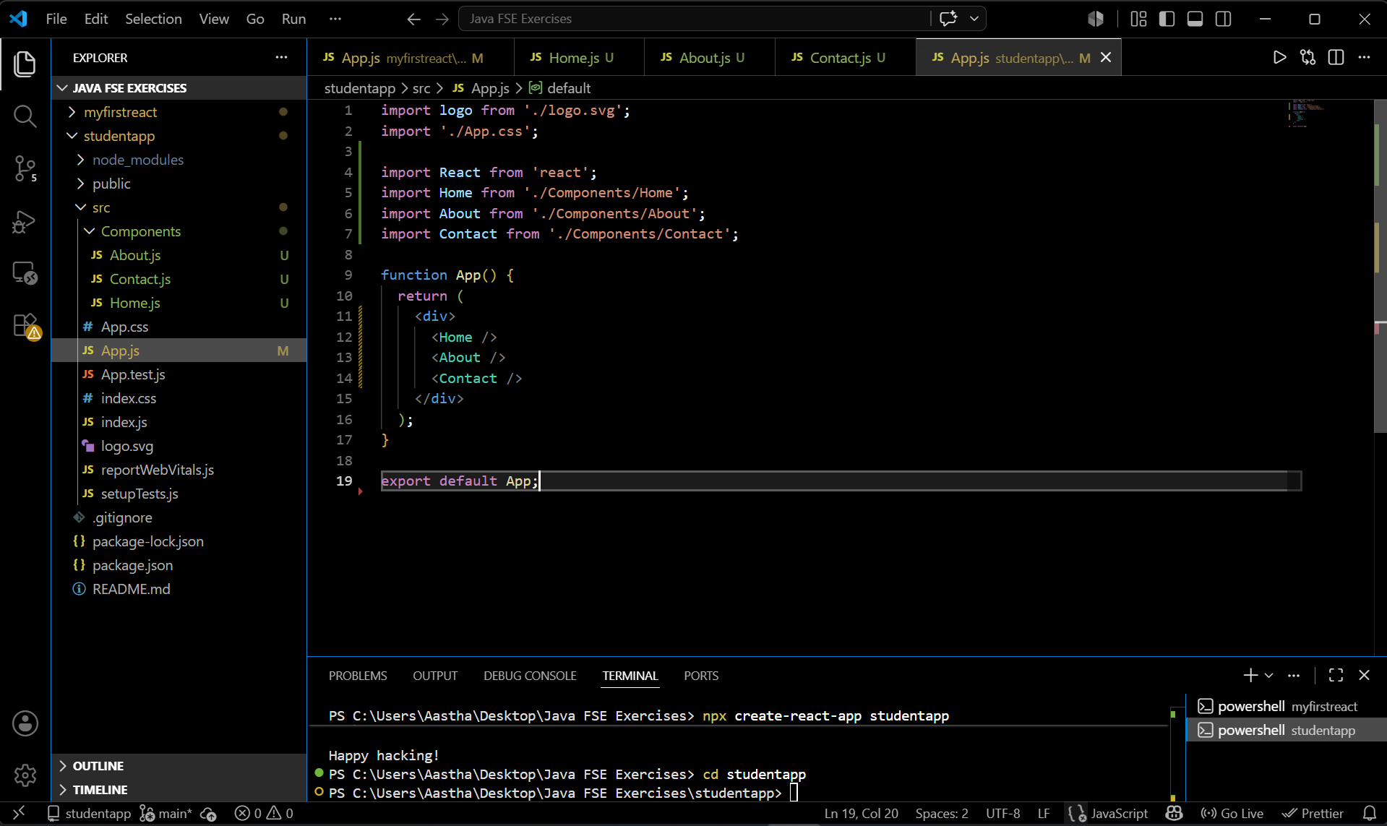

Step 8: Run the Application
Execute:
npm start

Step 9: Open Browser
Visit:
http://localhost:3000

Output
The browser displays:
Welcome to the Home page of Student Management Portal
Welcome to the About page of Student Management Portal
Welcome to the Contact page of Student Management Portal

Result
The React application ‘StudentApp’ was successfully created. Three class components (Home, About, and Contact) were created and rendered successfully on the webpage.

